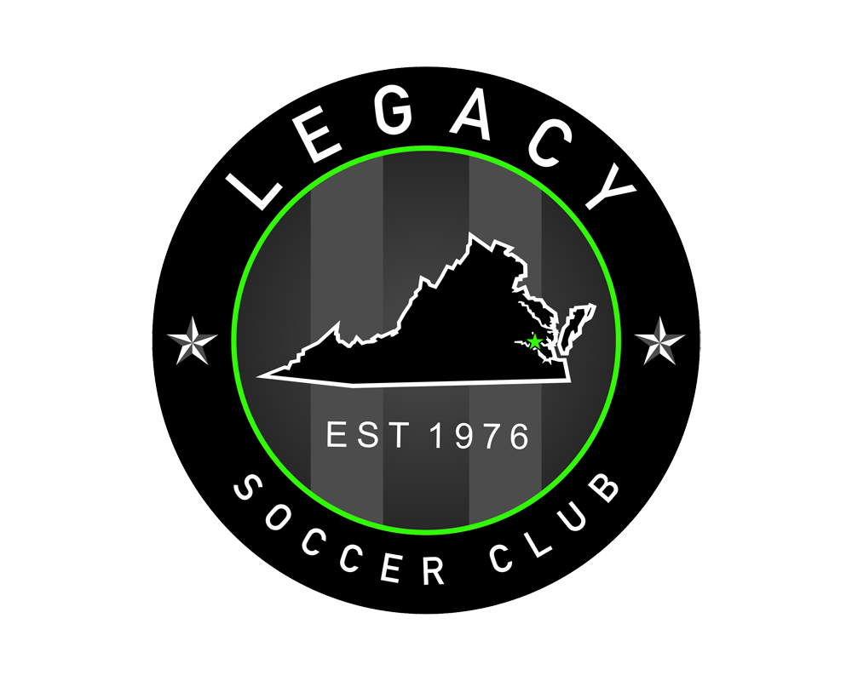
Fall 2017/Spring 2018 Coaches Slate
BOYS | CCL | Wmbg Wizards - Green |  |  |  | Wmbg Wizards - Black |  |  | Peninsula Wizards
U10 (2008) | -------------- | Dan Lidster |  |  |  | Travis Mulford |  |  | Bryce Fail
BOYS | CCL | Williamsburg Wizards |  |  |  |  | Peninsula Wizards |  |  | Wmbg Titans |  | Peninsula Titans
U11 (2007) | Jake Carel | Dan Lidster |  |  |  |  | Jon Gemmill |  |  | Derek Hanson |  | Moe Kanneh
U12 (2006) | Jake Carel | Phil Geyer |  |  |  |  | Jon Gemmill |  |  | Derek Hanson |  | Moe Kanneh
U13 (2005) | Scott Hines | Kendal Pressey |  |  |  |  | Chewy Giunti |  |  | ----------- |  | ----------
BOYS | CCL | Wizards  Green | Wizards  Black |  |  |  |  | Wmbg Titans |  |  | Peninsula Titans
U14 (2004) | Steve Shaw | Brendan Cook |  | Travis Mulford |  |  |  | Steve Grech |  |  | Brandon Boetger
U15 (2003) | Johnny Yu | Andrew Lieberman |  | Scott Peeke |  |  |  | ------------ |  |  | Brandon Boetger
U16 (2002) | Paul Membrino | Brendan Cook |  | Jamie Abston |  |  |  | Steve Grech |  |  | Matt Kraft
U17 (2001) | Bobby O’Brien | Jamie Abston |  | Phil Geyer |  |  |  | ------------
U18/U19  (00/99) | Justin Chezem  Phil Brown | Luke Taylor |  |  | Bobby Hodges |  |  | ------------ |  |  | -------------

GIRLS | CCL | Phoenix
U10 (2008) | ------------------ | Madeline Brass
U11 (2007) | Kevin Darcy | Matt Conti
U12 (2006) | Jen Mavis / Avery Saada
U13 (2005) | Shawn Trueblood | Steve Hermann
U14 (2004) | Kevin Darcy
U15 (2003) | Avery Saada | Jeff Imgrund
U16 (2002) | Phil Brown
U17 (2001) | Vanessa Mann | Jeff Imgrund / Tom Weih
U18 (2000) | Shawn Trueblood | Galen Small
U19 (1999) | Scot Cooper / Justin Chezem

**** TBA: Signifies that a coach will be announced at a later date, once 100% confirmed. We anticipate having teams in all areas represented by TBA and will update the coaches slate accordingly through the tryout process ****

We here at the Virginia Legacy Soccer Club are pleased to announce the 2017-2018 Coaching Slate. Below you will find the current bio page for all confirmed VLSC coaches. As we continue to confirm our staff we will continuously update the slate to keep you up to date on all the returning and new coaches to the club.

We are excited to boast one of the top coaching staffs in the region and are dedicated to bringing the best, motivated staff to all of our Legacy teams! The Legacy coaching staff is comprised of USSF/NSCAA (11 Coaches with an USSF “A” or “B” License) Licensed coaches who have experience playing and coaching at the High School, College and Professional levels. Each has a unique background but all with the same goal in mind - to make you the best soccer player you can be and make your soccer experience the best around. We aim to develop good players and good people on and off the field.

Jamie Abston- USSF 'D' License, NSCAA Regional Coaching Diploma, Current Poquoson HS JV Boy's head coach and Varsity Assistant.

Brandon Boetger – USSF ‘E’ License, Former Club Staff and Coach at SVU (Harrisonburg)

Madeline Brass - USSF ‘F’ License , captain of W&M Womens club team

Phil Brown - USSF 'C' License, Former Player at Milligan College

Jake Carel - USSF 'C' License, VYSA ODP Coach

Justin Chezem – USSF ‘B’ License, NSCAA Premier Diploma, Asst Coach CNU Men

Matt Conti - USSF ‘E’ License, former Club coach with Chesterfield United

Brendan Cook – Click here for coaching Bio

Scot Cooper - USSF ‘D’ License, Former Legacy CCL Girls Coach

Kevin Darcy – USSF ‘A’ License, NSCAA Premier Diploma, Head Coach of Legacy 76 NPSL

Bryce Fail - USSF ‘F’ License, working to obtain E. Former Legacy player

Jon Gemmill - USSF 'F' License

Phil Geyer- USSF 'E' License, Former State Champion at Jamestown HS, Former Collegiate Player at Roanoke College.

David “Chewy” Giunti- USSF 'F' License - Former Collegiate Player for Methodist College

Steve Grech- USFF 'F' License, Former Semi-Pro player throughout various leagues in NY.

Steve Hermann - USSF ‘F’ License , Former College Player for Christopher Newport University (CNU)

Scott Hines - USSF 'B' License, 20 Years Coaching Experience, Former College Player at Western Michigan University

Bobby Hodges- USSF 'E' License, NSCAA Level 5 Diploma, Former Collegiate player at Radford University.

Jeff Imgrund- USSF ‘F’ License –Former College Player Averett University

Matt Kraft - USSF ‘F’ License
Dan Lidster – USSF ‘F’ License – Former College Player for Old Dominion University

Andrew Lieberman- USSF 'E' License, Head JV Boy's Coach at Hampton Roads Academy
Vanessa Mann – USSF ‘A’ License, Click here for coaching Bio

Jen Mavis – USSF ‘B’ License, Click here for coaching Bio

Travis Mulford – USSF ‘F’ License, former college player UNC Pembroke and Legacy 76

Bobby O’Brien - Click here for coaching Bio

Scot Peeke - USSF ‘E’ License – Longtime Legacy Coach

Kendall Pressey – Click here for coaching Bio

Avery Saada - USSF ‘E’ License

Steve Shaw - Click here for coaching Bio

Galen Small - USSF 'D' License, Former Player at CNU, Head Coach Varsity Girl's - Grafton High School.

Alex Spirn – Click here for coaching Bio

Luke Taylor - USSF 'E' License, Former College Player at Bridgewater College, Head Coach at Bruton HS

Shawn Trueblood - Click here for coaching Bio

Johnny Yu - USSF 'A' License, USYSA National Youth License, Former ODP Head Coach

